Name(s)_______________________________________________ Period _______ Date _____________________

|  |  |  |
| --- | --- | --- |
|  | **Personal Web Page - Prepare** |  |

**Overview**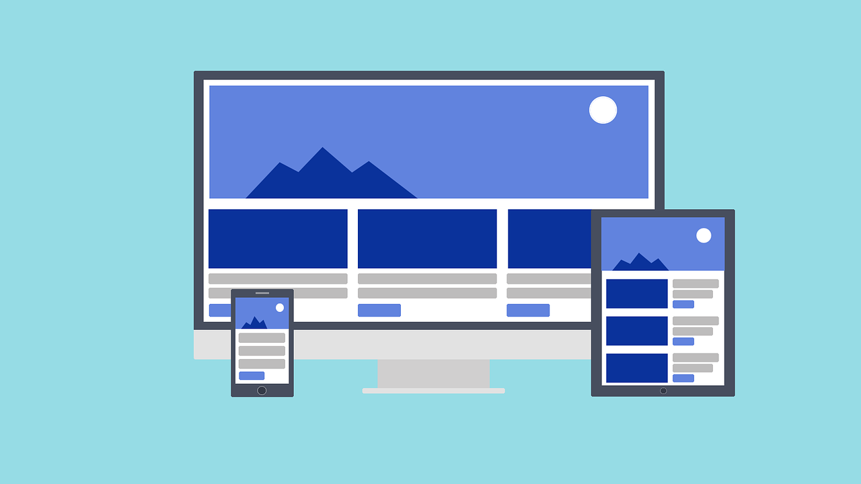

You’ve already **defined** your goal for your personal web page. Now you’ll have a chance to **prepare** to develop your page.

Your page will show that you can…

* Use HTML to structure a site
* Use CSS to style text and layout
* Respect copyright when using images
* Keep your personal information safe
* Write readable code and use good file names

## Step 1: Design your Page

**Describe your page**

The webpage is an advertisement webpage for a new smartwatch lineup, it contains four images with descriptions of the features the watch provides, the descriptions are arranged in paragraphs and have line breaks to separate the content and to ensure there is no page overflow, on top of every description is a h2 header to give an overview of what the description is talking about, the different segments are divided by the use of the div tag and are spaced from each other for more style.

**Sketch your page below.**

|  |
| --- |
| Last segment, contact and order details  Segment 3, stay connected  Segment 2, Keep fit  Segment 1, Introduction |

## Step 2: Describe your Styles

Next, decide the tags that you will use on your page and how each tag will be styled.

|  |  |
| --- | --- |
| Tag | Style Description |
| <body> | A smart watch background image that covers the whole page with the attribute background-size cover, a height of 100% and width of 100% |
| <p> | The paragraphs have a text color of #333333 and a font-family sans-serif |
| <h2> | The header is aligned center to be at the center of the page and will use a font-family of sans serif and margin properties to ensure it is in the correct position |
| <div> | It contains the over layer for the background image, it has a background-color #2A37BF, position absolute to keep it on top of the image and an opacity of 0.8 so that the background image is visible |

## 

## Step 3: Find Your Images

Next, you should find all the images that you need and download them to your computer. **Rename each image** and write the file name here. Don’t forget to write down all the information about the image, such as the author, title, source, and license it is covered under.

|  |  |
| --- | --- |
| Image File Name | Image Information (Author, Title, Source, License, etc.) |
| Background-watch.jpg | Author: Torsten Dettlaff  Title: Digital smart watch  Source: <https://www.pexels.com/photo/black-and-silver-car-gear-shift-lever-437036/>  License: free to use |
| Keep-fit.jpg | Author: Pixabay  Title: person-wearing-white-silicone-strap-black-smartwatch  Source: <https://www.pexels.com/photo/person-wearing-white-silicone-strap-black-smartwatch-267394/>  License: free to use |
| Watch-intro.jpg | Author: Kayjeton technology  Title: Heart rate monitor smart watch  Source: <https://www.alibaba.com/product-detail/2021-Heart-Rate-Monitor-Smart-Watch_60764608476.html>  License: free to use |
| Stay-connevted.jpg | Author: fancycrave1  Title: smart-watch-apple-technology-style  Source: <https://pixabay.com/photos/>  License: free to use |
| Voice-control.jpg | Author: information age  Title: voice control  Source: <https://s27389.pcdn.co/wp-content/uploads/AdobeStock_79969378-1024x440.jpeg.optimal.jpeg>  License: free to use |